4.6.2 Triple Integrals in Spherical Coordinates

Like cylindrical coordinates, the spherical coordinate system is used to make certain triple integrals easy to evaluate. A picture of a point given by its spherical coordinates is:

When trying to derive equations that relate rectangular and spherical coordinates we obtain the following right triangle from the above picture:
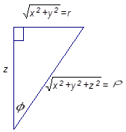

From this right triangle we immediately notice that and .
We know from the previous section that and .

From these facts we obtain the following.

To Convert from Spherical to Rectangular Coordinates:
Use the following equations: , , and .

Remark: We restrict so that , and we restrict so that . This means that .

Example 1: Describe the graph of the following equation in spherical: .
The graph is the top half of a cone extenuating from the origin. Moreover any ray drawn on the cone creates an angle of measure with the positive z-axis.

Note: In order to get an answer to the above example, one could have noticed that the z coordinate of every point on the graph is nonnegative and:
The final equation is the rectangular version of the top half of a cone.
Fact: Suppose that where , , and both and are continuous and nonnegative for all possible values of and . Then, assuming that is continuous, we have that
.

Note: The above formula is partially justified on pages 1051 and 1052 of the textbook.
Note: Since theta and phi are bounded by constants their order can be reversed.
Note: The general procedure for setting up triple integrals as iterated integrals does not extend in a natural way to spherical since, currently; it doesn’t make sense to project onto the -plane (this will be revisited in section 4.7). We will therefore take a more intuitive approach.

Example 2: Evaluate where .

We note that in spherical coordinates we can write B as: .
This means that in spherical the triple integral becomes:

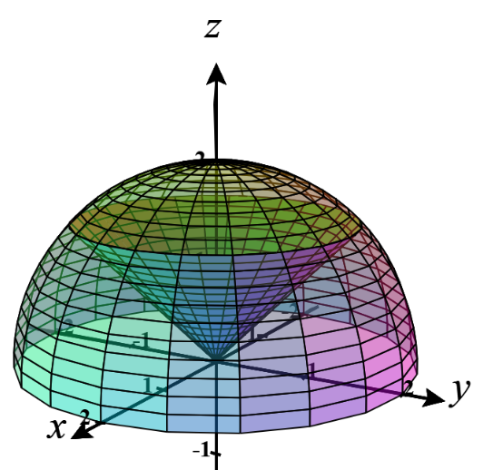
Example 3: Find the exact volume of the solid that lies inside the sphere , above the xy-plane, and below the half-cone .

We want the volume of .
We draw a picture of the region to help think about this.

We need to define this region in terms of and we have two ways of proceeding.

Geometric Approach:
It is quite easy to note that by just looking at the picture we can see that in order to view the entire region E we need to have and . So we just need to determine the range of values on the angle that are needed here.
We focus on the red triangle shown in the picture at the right and use its side lengths to make some determinations about the ranges on .
First note that the hypothenuse of this right triangle is 2 (the radius of the sphere).
The horizontal leg of this triangle is the radius of the circle where the cone intersects the sphere. So, we need to determine this intersection. Note that the sphere and cone intersect when
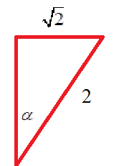
Therefore, the radius of this circle of intersection is .

So we can say that and thus the angle between the z-axis and the hypothenuse must be .

This implies that .

So, we know that .

Algebraic Approach:
In spherical coordinates we note that .

We also note that . Since we know that , we know that . Then, since we know that , we know that .

Now, we note that (we can assume that since using or will not affect the integral).
Then, since we know that and .
Thus, .

So, we know that .

Regardless of which of the above approaches we take we see that the volume is

.

